LAB 10 - Semaphore Manipulation

1) #include <stdio.h>
#include <pthread.h>
#include <semaphore.h>
#include <unistd.h>
void* threadHi(void* arg)
{
int i;
//critical section
for(i=1;i<=100;i++)
printf("%s ","hi");
}
void* threadHello(void* arg)
{
int i;
//critical section
for(i=1;i<=100;i++)
printf("%s ","hello");
}
int main()
{
pthread_t t1,t2;
pthread_create(&t1,NULL,threadHi,NULL);
pthread_create(&t2,NULL,threadHello,NULL);
pthread_join(t1,NULL);
pthread_join(t2,NULL);
return 0;
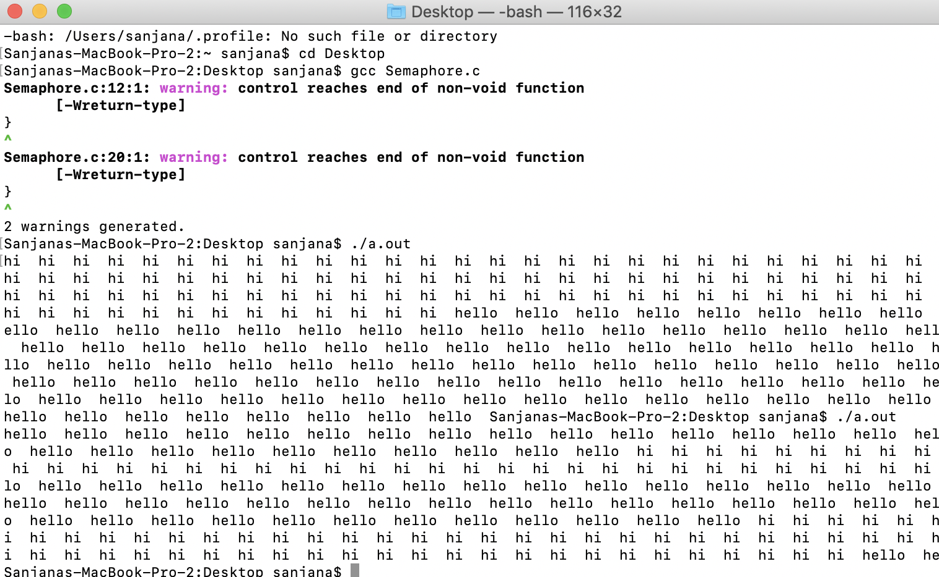
}

2) #include <stdio.h>
#include <pthread.h>
#include <semaphore.h>
#include <unistd.h>
sem_t mutex;
void* threadHi(void* arg)
{
int i;
//wait
sem_wait(&mutex);
//printf("\nEntered..\n");
//critical section
for(i=1;i<=100;i++)
printf("%s “,"hi");
//sleep(2);
//signal
//printf("\nJust Exiting...\n");
sem_post(&mutex);
}
void* threadHello(void* arg)
{
int i;
//wait
sem_wait(&mutex);
//printf("\nEntered..\n");
//critical section
for(i=1;i<=100;i++)
printf("%s ","hello");
//signal
//printf("\nJust Exiting...\n");
sem_post(&mutex);
}
int main()
{
sem_init(&mutex, 0, 1);
//0 indicates semaphore mutex is shared by multiple threads of a procees
//1 indicates the initial value.
pthread_t t1,t2;
pthread_create(&t1,NULL,threadHi,NULL);
pthread_create(&t2,NULL,threadHello,NULL);
pthread_join(t1,NULL);
pthread_join(t2,NULL);
sem_destroy(&mutex);
return 0;
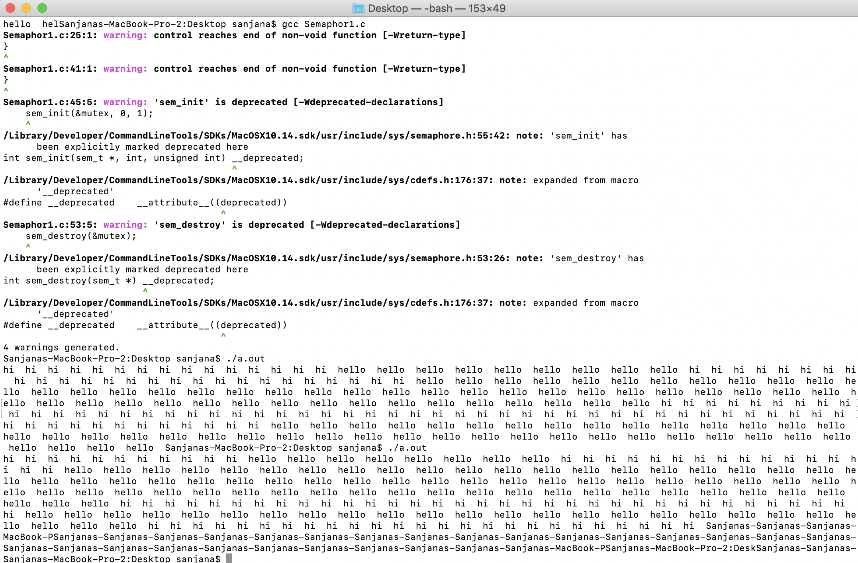
}

3) #include <stdio.h>
#include <pthread.h>
#include <semaphore.h>
#include <unistd.h>
sem_t mutex;
int val=0;
void* threadfn(void* arg)
{
int val=0;
//wait
//sem_wait(&mutex);
//printf("\nEntered..\n");
//critical section
while(val <=100)
printf("%d ",val++);

//sleep(2);
//signal
//printf("\nJust Exiting...\n");
// sem_post(&mutex);
}
int main()
{
sem_init(&mutex, 0, 1);
//0 indicates semaphore mutex is shared by multiple threads of a procees
//1 indicates the initial value.
pthread_t t1,t2;
pthread_create(&t1,NULL,threadfn,NULL);
pthread_create(&t2,NULL,threadfn,NULL);
pthread_join(t1,NULL);
pthread_join(t2,NULL);
sem_destroy(&mutex);
return 0;
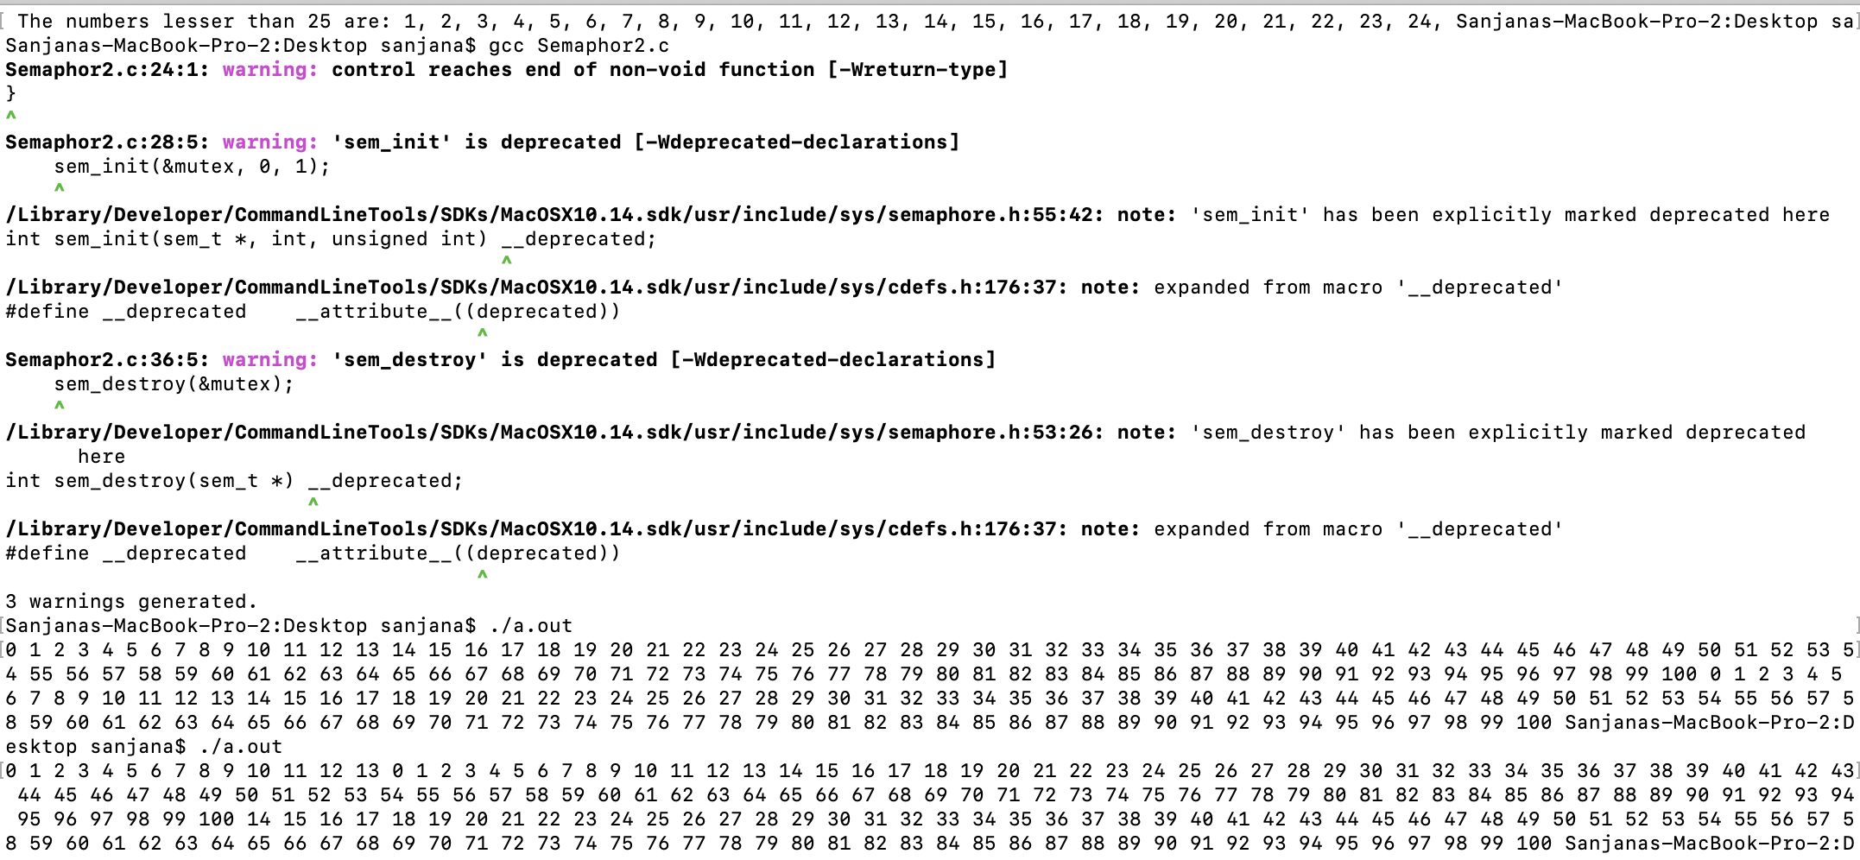
}

4) Get a number through the main function and pass it as a parameter where the first thread should print the first n natural numbers and a second thread should print factors of n.
#include<stdio.h>
#include<pthread.h>
#include<semaphore.h>
#include<unistd.h>
sem_t mutex;
void* factors(void* arg)
{
int* a=arg;
int b,i;
b= *a;
sem_wait(&mutex);
printf("\n The factors of the number %d are: ", b);
for(i=1;i<=b;i++)
{
if(b%i==0)
printf("%d, ",i);
}
printf("Exit factors \n");
sem_post(&mutex);
}
void* numbers(void* arg)
{
int* a=arg;
int b,i;
b= *a;
sem_wait(&mutex);
printf("\n The numbers lesser than %d are: ",b);
for(i=1;i<b;i++)
printf("%d, ", i);
sem_post(&mutex);
}
int main()
{
sem_init(&mutex,0,1);
int a;
printf("Enter number to print factors and numbers preceeding it: ");
scanf("%d", &a);
pthread_t t1,t2;
pthread_create(&t1,NULL,factors,&a);
pthread_create(&t2,NULL,numbers,&a);
pthread_join(t1,NULL);
pthread_join(t2,NULL);
sem_destroy(&mutex);
return(0);



